1. **Sequential Search**: In this, the list or array is **traversed sequentially**, and every element is checked. For example: [Linear Search](https://www.geeksforgeeks.org/linear-search/).

***Time Complexity- o(n)***

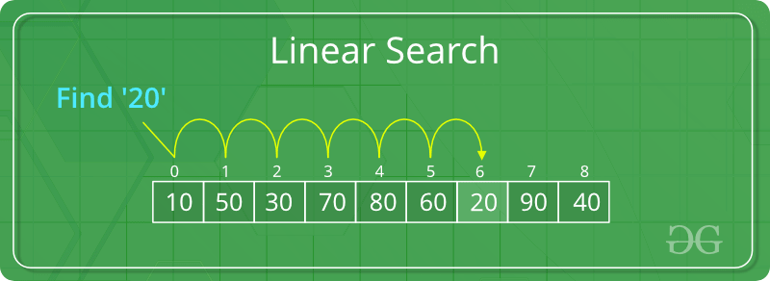

1. **Interval Search**: These algorithms are specifically designed for searching in **sorted data-structures**. These type of searching algorithms are much more efficient than Linear Search as they repeatedly target the centre of the search structure and divide the search space in half. For Example: [Binary Search](https://www.geeksforgeeks.org/binary-search/).

***Time Complexity- o(log2(n))***

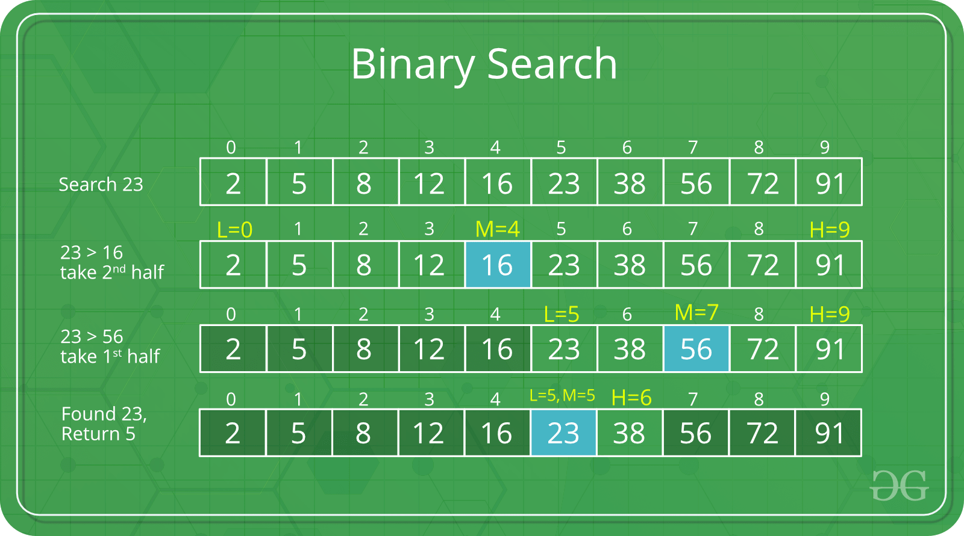

***Time taken by binary search algorithm***

There's a mathematical function that means the same thing as the number of times we repeatedly halve, starting at n, until we get the value 1: the **base-2 logarithm of n**. That's most often written as log2​*n*